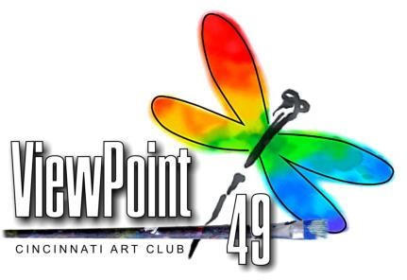

NEWS RELEASE

INFORMATION

Cincinnati Art Club
1021 Parkside Place
Cincinnati, OH 45202
Contact: Ray Burt 513 312 4013
rayburt@live.com

Local Artist Accepted in ViewPoint 49, 2017
National Juried Art Exhibition

Artist Lu Fuller of Mays Lick has had her artwork, “Autumn Tapestry,” an original watercolor, accepted into ViewPoint 49, 2017, a national juried art competition sponsored by the Cincinnati Art Club.
This marks the 49th year for this annual competition which comprises 80 works by national artists in various media.

ViewPoint 49, 2017 will hold an artist’s reception and awards ceremony which is open to the public at Greenwich House Gallery, 2124 Madison Road, Cincinnati, Ohio 45208 on Friday October 6th from 7:00 to 10:00 PM. The exhibition will continue through November 4, 2017. Hours are Monday through Saturday 11:00AM - 5:00PM.

A variety of awards will be given: First Place - $3,000; Second Place - $1,200; Third Place - $750; plus additional cash prizes. ViewPoint 49, 2017 exhibitions & awards were selected by a three panel jury. Additional information can be found on the Cincinnati Art Club website.

Founded in 1890, The Cincinnati Art Club is one of the oldest and most active nonprofit art organizations in the United States. For details visit www.cincinnatiartclub.com.

Lu Fuller’s artwork can be viewed locally at “All Occasions” 229 Market Street in Maysville, Kentucky.

